

**REAL TIME FACE ATTENDANCE SYSTEM**

**A PROJECT REPORT**

***Submitted by***

**ALEX PANDIAN M (713919104002)**

**HEMANTH KUMAR P (713919104012)**

**SRINIVASAN S (713919104034)**

***in partial fulfillment for the award of the degree***

***of***

**BACHELOUR OF ENGINEERING**

***in***

**COMPUTER SCIENCE AND ENGINEERING**

**SRI RANGANATHAR**

**INSTITUTE OF ENGINEERING AND TECHNOLOGY,**

**COIMBATORE**

# **ANNA UNIVERSITY :: CHENNAI 600 025**

**MAY 2023**

**ANNA UNIVERSITY :: CHENNAI 600 025**

**BONAFIDE CERTIFICATE**

Certified that this project report **“REAL TIME FACE ATTENDENCE SYSTEM”** is the bonafide work of **ALEX PANDIYAN M (713919104002), HEMANTH KUMAR P (713919104012), and SRINIVASAN S (713919104034)** who carried out the project work under my supervision.

|  |  |
| --- | --- |
| **SIGNATURE** | **SIGNATURE** |
| **Dr. S. LAVANYA M.Tech., Ph.D.,** | **S. KALAIVANI M.Tech.,** |
| **HEAD OF THE DEPARTMENT** | **SUPERVISOR** |
| Associate Professor | Assistant Professor |
| Department of Computer Science and Engineering | Department of Computer Science and Engineering |
| Sri Ranganathar Institute of  Engineering and Technology | Sri Ranganathar Institute of  Engineering and Technology |
| Coimbatore-641 110 | Coimbatore-641 110 |

Submitted for the Project Viva -Voce held on ……………….

**INTERNAL EXAMINER EXTERNAL EXAMINER**

# **ACKNOWLEDGEMENT**

At this pleasing moment of having successfully completed our project, we wish to convey our sincere thanks to the management of our college and our beloved chairman **Dr. V. NARAYANASAMY**, for this kind patronage.

We would like to express our sincere thanks and profound gratitude to our principal **Dr. H. GANESAN**, **M.E., PhD.,** who has greatly helped in the success of the project by providing us with the necessary equipment’s and facilities required.

We extend our overwhelming thanks to **Dr. S. LAVANAYA, M.Tech, MBA, Ph.D,** Head of the Department, Department of Computer Science and Engineering, Sri Ranganathar Institute of Engineering and Technology for her prominent support, guidanceand encouragement during this project.

We would like to thank our guide **S. KALAIVANI M.Tech,** Assistant Professor, Department of Computer Science and Engineering, Sri Ranganathar Institute of Engineering and Technology for her motivation and guidance throughout the duration of the project, by way of valuable suggestions and ideas.

Its our prime duty to thank all technical, supporting staffs and our friends who helped directly and indirectly to complete our project successfully.

#### ABSTRACT

Face is the representation of one’s identity. Hence, we have proposed an automated student attendance system based on face recognition. Face recognition system is very useful in life applications especially in security control systems. The airport protection system uses face recognition to identify suspects and FBI (Federal Bureau of Investigation) uses face recognition for criminal investigations. In our proposed approach, firstly, video framing is performed by activating the camera through a user- friendly interface. The face ROI is detected and segmented from the video frame by using Viola-Jones algorithm. In the pre-processing stage, scaling of the size of images is performed if necessary in order to prevent loss of information. The median filtering is applied to remove noise followed by conversion of color images to grayscale images. After that, contrast-limited adaptive histogram equalization (CLAHE) is implemented on images to enhance the contrast of images. In face recognition stage, enhanced local binary pattern (LBP) and principal component analysis (PCA) is applied correspondingly in order to extract the features from facial images. In our proposed approach, the enhanced local binary pattern outperform the original LBP by reducing the illumination effect and increasing the recognition rate. Next, the features extracted from the test images are compared with the features extracted from the training images. The facial images are then classified and recognized based on the best result obtained from the combination of algorithm, enhanced LBP and PCA. Finally, the attendance of the recognized student will be marked and saved in the excel file. The student who is not registered will also be able to register on the spot and notification will be given if students sign in more than once. The average accuracy of recognition is 100 % for good quality images, 94.12 % of low-quality images and 95.76 % for Yale face database when two images per person are trained.

#### TABLE OF CONTENTS

|  |  |  |
| --- | --- | --- |
| **CHAPTER NO** | **TITLE** | **PAGE NO** |
|  | **ACKNOWLEDGEMENT** | **III** |
|  | **ABSTRACT** | **IV** |
|  | **TABLE OF CONTENTS** | **V** |
|  | **LIST OF TABLES** | **VIII** |
|  | **LIST OF FIGURES** | **IX** |
|  | **LIST OF SYMBOLS / ABBREVIATIONS** | **XI** |
|  | **LIST OF APPENDICES** | **XII** |
| **1** | **INTRODUCTION** | **1** |
|  | 1.1 Background | 1 |
|  | 1.2 Problem statement | 3 |
|  | 1.3 Aims and Objectives | 4 |
|  | 1.4 Thesis organization | 4 |
| **2** | **LITERATURE REVIEW** | **5** |
|  | 2.1 Student Attendance System | 5 |
|  | 2.2 Face Detection | 6 |
|  | 2.2.1 Viola-Jones Algorithm | 9 |
|  | 2.3 Pre-Processing | 11 |
|  | 2.4 Feature Extraction | 13 |
|  | 2.4.1 Types of Feature Extraction | 18 |
|  | 2.5 Feature Clarification and Face Recognition | 19 |
|  | 2.6 Evaluation | 20 |
| **3** | **METHODOLOGY** | **22** |
|  | 3.1 Methodology Flow | 22 |
|  | 3.2 Input Images | 22 |
|  | 3.3 Face Detection | 24 |
|  | 3.3.1 Working Principle of Original LBP | 24 |
|  | 3.3.2 Working Principle of Proposed LBP | 26 |
|  | 3.3.3 Working Principle of PCA | 28 |
|  | 3.4 Feature Classification | 29 |
|  | 3.4.1 Subjective Selection Algorithm  and Face Recognition | 29 |
| **4** | **RESULT AND DISCUSSION** | **31** |
|  | 4.1 Result | 31 |
|  | 4.2 Discussion | 33 |
| **5** | **SYSTEM REQUIREMENTS** | **35** |
|  | 5.1 Hardware Specifications | 35 |
|  | 5.2 Software Specifications | 35 |
|  | 5.3 Python librarys and modules | 36 |
| **6** | **CONCLUSION AND RECOMMENDATION** | 40 |
|  | 6.1 Conclusion | 40 |
|  | 6.2 Recommendation | 41 |
|  | **APPENDIX** | 42 |
|  | REFERENCES | 52 |
|  |  |  |
|  |  |  |
|  |  |  |

#### LIST OF TABLES

|  |  |  |
| --- | --- | --- |
| **TABLE** | **TITLE** | **PAGE NO** |
| 2.1 | Advantages & Disadvantages of Different Biometric System (Arun Katara et al. 2017) | 5 |
| 2.2 | Factors Causing Face Detection Difficulties (S.Aanjanadevi et al. 2017) | 6 |
| 2.3 | Advantages & Disadvantages of Face Detection Methods (Varsha Gupta and Dipesh Sharma, 2014) | 8 |
| 2.4 | Summary of Contrast Improvement | 13 |
| 2.5 | Summary of feature extraction, the accuracy obtained from Handbook of Research on Emerging Perspectives in Intelligent Pattern Recognition (NK Kamila, 2015) | 21 |

#### LIST OF FIGURES

|  |  |  |
| --- | --- | --- |
| **FIGURE** | **TITLE** | **PAGE NO** |
| 1.1 | Block Diagram of the General Framework | 4 |
| 2.1 | Haar Feature (Docs.opencv.org, 2018) | 9 |
| 2.2 | Integral of Image (Srushti Girhe et al., 2015) | 10 |
| 2.3 | False Face Detection (Kihwan Kim, 2011) | 11 |
| 2.4 | Images show Checkerboard Effect significantly increasing from left to right (Gonzalez, R. C., & Woods, 2008) | 12 |
| 2.5 | PCA Dimension Reduction (Liton Chandra Paul and Abdulla Al Sumam, 2012) | 15 |
| 2.6 | Class Separation in LDA (Suman Kumar Bhattacharyya and Kumar Rahul, 2013) | 16 |
| 2.7 | LBP Operator (Md. Abdur Rahim et.al, 2013) | 17 |
| 2.8 | Artificial Neural Network (ANN) (Manisha M. Kasar et al., 2016) | 18 |
| 2.9 | Deepface Architecture by Facebook (Yaniv Taigman et al, 2014) | 18 |
| 2.10 | Feature Extraction (Yaniv Taigman et al, 2014) | 19 |
| 3.1 | Sample Images in Yale Face Database(Cvc.cs.yale.edu, 1997) | 24 |
| 3.2 | Sample of High Quality Images | 24 |
| 3.3 | Sample of Low Quality Images | 25 |
| 3.4 | Example of LBP Conversion | 26 |
| 3.5 | LBP with Different Radius Sizes | 29 |
| 3.6 | Proposed LBP Operator with Radius 2 Encoding Pattern. | 29 |
| 3.7 | Histogram of Image Blocks | 30 |
| 3.8 | Subjective Selection Algorithm | 32 |
| 4.1 | Real Time Face Recognition (Automated) | 33 |
| 4.2 | Image Browsing and Face Recognition | 34 |
| 4.3 | False Recognition is suppressed | 34 |
| 4.4 | Images of Students With or Without Wearing Glasses | 38 |
| 4.5 | Training Image VS Testing Image | 38 |
|  |  |  |
|  |  |  |
|  |  |  |
|  |  |  |
|  |  |  |

#### LIST OF SYMBOLS / ABBREVIATIONS

χ2 Chi-square statistic

𝑑 distance

𝑥 input feature points

𝑦 trained feature points

𝑚𝑥 mean of x

𝑆𝑥 covariance matrix of x

𝑋𝑐 x coordinate of center pixel

𝑌𝑐 y coordinate of center pixel

𝑋𝑝 x coordinate of neighbour pixel

𝑌𝑝 y coordinate of neighbour pixel

𝑅 radius

𝜃 angle

𝑃 total sampling points

𝑁 total number of images

𝑀 length and height of images

𝛤𝑖 column vector

𝜑 mean face

Φ𝑖 mean face subtracted vector

𝐴 matrix with mean face removed

𝐴𝑇 transpose of 𝐴

𝐶 covariance matrix

𝑢𝑖 eigenvector of 𝐴𝐴𝑇

𝑣𝑖 eigenvector of 𝐴𝑇𝐴

λ eigenvalue

𝑈 eigen face

𝑈𝑇 transpose of eigen face

Ω projected image

Ω𝑖 projected image vector

#### CHAPTER 1

**INTRODUCTION**

The main objective of this project is to develop face recognition based automated student attendance system. In order to achieve better performance, the test images and training images of this proposed approach are limited to frontal and upright facial images that consist of a single face only. The test SSSimages and training images have to be captured by using the same device to ensure no quality difference. In addition, the students have to register in the database to be recognized. The enrolment can be done on the spot through the user-friendly interface.

#### Background

Face recognition is crucial in daily life in order to identify family, friends or someone we are familiar with. We might not perceive that several steps have actually taken in order to identify human faces. Human intelligence allows us to receive information and interpret the information in the recognition process. We receive information through the image projected into our eyes, by specifically retina in the form of light. Light is a form of electromagnetic waves which are radiated from a source onto an object and projected to human vision. Robinson-Riegler, G., & Robinson-Riegler, B. (2008) mentioned that after visual processing done by the human visual system, we actually classify shape, size, contour and the texture of the object in order to analyse the information.

The analysed information will be compared to other representations of objects or face that exist in our memory to recognize. In fact, it is a hard challenge to build an automated system to have the same capability as a human to recognize faces. However, we need large memory to recognize different faces, for example, in the Universities, there are a lot of students with different race and gender, it is impossible to remember every face of the individual without making mistakes. In order to overcome human limitations, computers with almost limitless memory, high processing speed and power are used in face recognition systems.

The human face is a unique representation of individual identity. Thus, face recognition is defined as a biometric method in which identification of an individual is performed by comparing real-time capture image with stored images in the database of that person (Margaret Rouse, 2012).

Nowadays, face recognition system is prevalent due to its simplicity and awesome performance. For instance, airport protection systems and FBI use face recognition for criminal investigations by tracking suspects, missing children and drug activities ([Robert Silk](http://www.travelweekly.com/Robert-Silk), 2017). Apart from that, Facebook which is a popular social networking website implement face recognition to allow the users to tag their friends in the photo for entertainment purposes ([Sidney Fussell](https://kinja.com/sidneyfussell#_ga%3D2.33904934.647560575.1521956578-2116359232.1521956578), 2018).

Furthermore, Intel Company allows the users to use face recognition to get access to their online account (Reichert, C., 2017). Apple allows the users to unlock their mobile phone, iPhone X by using face recognition (deAgonia, M., 2017).

The work on face recognition began in 1960. Woody Bledsoe, Helen Chan Wolf and Charles Bisson had introduced a system which required the administrator to locate eyes, ears, nose and mouth from images. The distance and ratios between the located features and the common reference points are then calculated and compared. until today (Ashley DuVal, 2012).

#### Problem Statement

Traditional student attendance marking technique is often facing a lot of trouble. The face recognition student attendance system emphasizes its simplicity by eliminating classical student attendance marking technique such as calling student names or checking respective identification cards. There are not only disturbing the teaching process but also causes distraction for students during exam sessions. Apart from calling names, attendance sheet is passed around the classroom during the lecture sessions. The lecture class especially the class with a large number of students might find it difficult to have the attendance sheet being passed around the class. Thus, face recognition student attendance system is proposed in order to replace the manual signing of the presence of students which are burdensome and causes students get distracted in order to sign for their attendance. Furthermore, the face recognition based automated student attendance system able to overcome the problem of fraudulent approach and lecturers does not have to count the number of students several times to ensure the presence of the students.

The paper proposed by Zhao, W et al. (2003) has listed the difficulties of facial identification. One of the difficulties of facial identification is the identification between known and unknown images. In addition, paper proposed by Pooja G.R et al. (2010) found out that the training process for face recognition student attendance system is slow and time-consuming. In addition, the paper proposed by [Priyanka](http://ieeexplore.ieee.org/search/searchresult.jsp?searchWithin=%22Authors%22%3A.QT.Priyanka%20Wagh.QT.&newsearch=true) [Wagh](http://ieeexplore.ieee.org/search/searchresult.jsp?searchWithin=%22Authors%22%3A.QT.Priyanka%20Wagh.QT.&newsearch=true) et al. (2015) mentioned that different lighting and head poses are often the problems that could degrade the performance of face recognition based student attendance system.

Hence, there is a need to develop a real time operating student attendance system which means the identification process must be done within defined time constraints to prevent omission. High accuracy and fast computation time will be the evaluation points of the performance.

#### Aims and Objectives

The objective of this project is to develop face recognition based automated student attendance system. Expected achievements in order to fulfill the objectives are:

* To detect the face segment from the video frame.
* To extract the useful features from the face detected.
* To classify the features in order to recognize the face detected.
* To record the attendance of the identified student.



Figure 1.1 Block Diagram of the General Framework

#### 1.4 Thesis Organization

Chapter 2 includes a brief review of the approaches and studies that have been done previously by other researchers whereas Chapter 3 describe proposed methods and approaches used to obtain the desired output. The results of the proposed approach would be presented and discussed in Chapter 4. The conclusion, as well as some recommendations would be included in Chapter 6.

#### CHAPTER 2

**LITERATURE REVIEW**

#### Student Attendance System

Arun Katara et al. (2017) mentioned disadvantages of RFID (Radio Frequency Identification) card system, fingerprint system and iris recognition system. RFID card system is implemented due to its simplicity. However, the user tends to help their friends to check in as long as they have their friend’s ID card. The fingerprint system is indeed effective but not efficient because it takes time for the verification process so the user has to line up and perform the verification one by one. However for face recognition, the human face is always exposed and contain less information compared to iris. Iris recognition system which contains more detail might invade the privacy of the user. Voice recognition is available, but it is less accurate compared to other methods. Hence, face recognition system is suggested to be implemented in the student attendance system.

Table 2.1 Advantages & Disadvantages of Different Biometric System (Arun Katara et al., 2017)

|  |  |  |
| --- | --- | --- |
| **System type** | **Advantages** | **Disadvantages** |
| RFID card system | Simple | Fraudulent usage |
| Fingerprint system | Accurate | Time-consuming |
| Voice recognition  system | - | Less accurate compared to others |
| Iris recognition  system | Accurate | Privacy Invasion |

#### Face Detection

Difference between face detection and face recognition are often misunderstood. Face detection is to determine only the face segment or face region from image, whereas face recognition is to identify the owner of the facial image. S.Aanjanadevi et al. (2017) and Wei-Lun Chao (2007) presented a few factors which cause face detection and face recognition to encounter difficulties.These factors consist of background, illumination, pose, expression, occlusion, rotation, scaling and translation. The definition of each factor is tabulated in Table 2.2.

Table 2.2 Factors Causing Face Detection Difficulties (S.Aanjanadevi et al., 2017)

|  |  |
| --- | --- |
| Background | Variation of background and environment around people in the image which affect the efficiency of face recognition. |
| Illumination | Illumination is the variation caused by various lighting environments which degrade the facial feature detection. |
| Pose | Pose variation means different angle of the acquired the facial image which cause distortion to recognition process, especially for Eigen face and Fisher face recognition method. |
| Expression | Different facial expressions are used to express feelings and emotions. The expression variation causes spatial relation change and the facial-feature shape change. |
| Rotation, scaling and translation | Transformation of images which might cause distortion of the original information about the images. |

There are a few face detection methods that the previous researchers have worked on. However, most of them used frontal upright facial images which consist of only one face. The face region is fully exposed without obstacles and free from the spectacles.

Akshara Jadhav et al. (2017) and by P. Arun Mozhi Devan et al. (2017) suggested Viola-Jones algorithm for face detection for student attendance system. They concluded that out of methods such as face geometry- based methods, Feature Invariant methods and Machine learning based methods, Viola-Jones algorithm is not only fast and robust, but gives high detection rate and perform better in different lighting condition. Rahul V. Patil and S. B. Bangar (2017) also agreed that Viola-Jones algorithm gives better performance in different lighting condition. In addition, in the paper by Mrunmayee Shirodkar et al. (2015), they mentioned that Viola-Jones algorithm is able to eliminate the issues of illumination as well as scaling and rotation. In addition, Naveed Khan Balcoh (2012) proposed that Viola-Jones algorithm is the most efficient among all algorithms for instance the AdaBoost algorithm, the FloatBoost algorithm, Neural Networks, the S-AdaBoost algorithm, Support Vector Machines (SVM) and the Bayes classifier.

Varsha Gupta and Dipesh Sharma (2014) studied Local Binary Pattern (LBP), Adaboost algorithm, local successive mean quantization transform (SMQT) Features, sparse network of winnows (SNOW) Classifier Method and Neural Network-based face detection methods in addition to Viola-Jones algorithm. They concluded that Viola-Jones algorithm has the highest speed and highest accuracy among all the methods. Other methods for instance Local Binary Pattern and SMQT Features have simple computation and able to deal with illumination problem, their overall performance is weaker than Viola-Jones algorithm for face detection. The advantages and disadvantages of the methods is studied and tabulated in Table 2.3.

Table 2.3 Advantages & Disadvantages of Face Detection Methods (Varsha Gupta and Dipesh Sharma, 2014)

|  |  |  |
| --- | --- | --- |
| Face detection method | Advantages | Disadvantages |
| Viola jones algorithm | 1. High detection speed 2. High accuracy. | 1. Long training time. 2. Limited head pose. 3. Not able to detect dark faces. |
| Local Binary pattern | 1. Simple computation. 2. High tolerance against the Monotonic illumination changes. | 1. Only used for binary and grey images. 2. Overall performance is   inaccurate compared to Viola-Jones algorithm. |
| AdaBoost algorithm  (part of Viola  jones algorithm) | Need not to have any prior knowledge about face structure. | The result highly depends on the training data and affected by weak classifiers. |
| SMQT Features and SNOW Classifier Method | 1. Capable to deal with lighting problem in object detection. 2. Efficient in computation. | The region contain very similar to grey value regions will be misidentified as face. |

#### 2.2.1 Viola-Jones Algorithm

Viola-Jones algorithm which was introduced by P. Viola, M. J. Jones (2001) is the most popular algorithm to localize the face segment from static images or video frame. Basically the concept of Viola-Jones algorithm consists of four parts. The first part is known as Haar feature, second part is where integral image is created, followed by implementation of Adaboost on the third part and lastly cascading process.

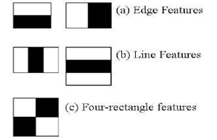

Figure 2.1 Haar Feature (Docs.opencv.org, 2018)

Viola-Jones algorithm analyses a given image using Haar features consisting of multiple rectangles (Mekha Joseph et al., 2016). Figure 2.1 shows several types of Haar features. The features perform as window function mapping onto the image. A single value result, which representing each feature can be computed by subtracting the sum of the white rectangle(s) from the sum of the black rectangle(s) (Mekha Joseph et al., 2016). The illustration is shown in Figure 2.2.

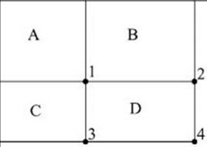

Figure 2.2 Integral of Image (Srushti Girhe et al., 2015)

The value of integrating image in a specific location is the sum of pixels on the left and the top of the respective location. In order to illustrate clearly, the value of the integral image at location 1 is the sum of the pixels in rectangle A. The values of integral image at the rest of the locations are cumulative. For instance, the value at location 2 is summation of A and B, (A + B), at location 3 is summation of A and C, (A + C), and at location 4 is summation of all the regions, (A + B + C + D) (Srushti Girhe et al., 2015). Therefore, the sum within the D region can be computed with only addition and subtraction of diagonal at location 4 + 1 − (2 + 3) to eliminate rectangles A, B and C.

Burak Ozen (2017) and Chris McCormick (2013), they have mentioned that Adaboost which is also known as ‘Adaptive Boosting’ is a famous boosting technique in which multiple “weak classifiers” are combined into a single “strong classifier”. The training set is selected for each new classifier according to the results of the previous classifier and determines how much weight should be given to each classifier in order to make it significant.

However, false detection may occur and it was required to remove manually based on human vision. Figure 2.3 shows an example of false face detection (circle with blue).

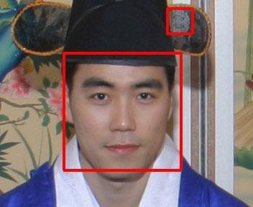

Figure 2.3 False Face Detection (Kihwan Kim, 2011)

#### 2.3 Pre-Processing

Subhi Singh et al. (2015) suggested cropping of detected face and colour image was converted to grayscale for pre-processing. They also proposed affine transform to be applied to align the facial image based on coordinates in middle of the eyes and scaling of image to be performed. Arun Katara et al (2017), Akshara Jadhav et.al (2017), Shireesha Chintalapati, and M.V. Raghunadh (2013), all of the 3 papers have proposed histogram equalization to be applied to facial image, and scaling of images was performed for pre-processing.

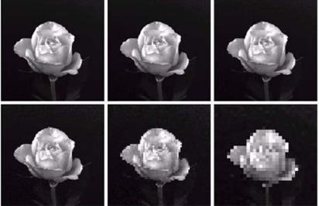

Figure 2.4 Images Show Checkerboard Effect Significantly Increasing from Left to Right (Gonzalez*,* R. C.*, &* Woods, 2008)

Table 2.4 Summary of Contrast Improvement

|  |  |  |  |
| --- | --- | --- | --- |
| **Method** | **Concept** | **Advantages** | **Disadvantages** |
| Histogram equalization | Contrast enhancement is performed by transforming the intensity values, resulting in uniformly distributed histogram. | 1. Less sensitive to noise. | 1. It depends on the global statistics of an image. 2. It cause over enhancement for some part, while peripheral region need more enhancement. |
| Contrast Limited Adaptive Histogram Equalization (CLAHE) | Unlike, HE which works on entire image, it works on small data regions. Each tile's contrast is Enhanced to ensure uniformly distributed histogram.Bilinear interpolation is then used to merge the neighbouring tiles. | 1. It prevent over enhancement as well as noise amplification. | 1. More sensitive to noise compared to histogram equalization. |

#### 2.4 Feature Extraction

The feature is a set of data that represents the information in an image. Extraction of facial feature is most essential for face recognition. However, selection of features could be an arduous task. Feature extraction algorithm has to be consistent and stable over a variety of changes in order to give high accuracy result.

There are a few feature extraction methods for face recognition. In the paper of Bhuvaneshwari et al. (2017), Abhishek Singh and Saurabh Kumar (2012) and Liton Chandra Paul and Abdulla Al Sumam (2012), they proposed PCA for the face recognition. D. Nithya (2015) also used PCA in face recognition based student attendance system. PCA is famous with its robust and high speed computation. Basically, PCA retains data variation and remove unnecessary existing correlations among the original features. PCA is basically a dimension reduction algorithm. It compresses each facial image which is represented by the matrix into single column vector. Furthermore, PCA removes average value from image to centralize the image data. The Principle Component of distribution of facial images is known as Eigen faces. Every single facial image from training set contributes to Eigen faces. As a result, Eigen face encodes best variation among known facial images. Training images and test images are then projected onto Eigen face space to obtain projected training images and projected test image respectively. Euclidean distance is computed by comparing the distance between projected training images and projected test image to perform the recognition. PCA feature extraction process includes all trained facial images. Hence, the extracted feature contains correlation between facial images in the training set and the result of recognition of PCA highly depends on training set image.

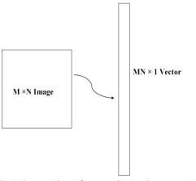

Figure 2.5 PCA Dimension Reduction (Liton Chandra Paul and Abdulla Al Sumam, 2012)

LDA (Linear discriminant analysis) also known as Fisher face is another popular algorithm for face recognition. In the paper by Suman Kumar Bhattacharyya and Kumar Rahul (2013), LDA was proposed for face recognition. LDA extract features by grouping images of the same class and separate images of different classes. LDA is able to perform well even with different facial expressions, illumination and pose due to its class separation characteristic. Same class is defined by facial images of the same individual, but with different facial expressions, varying lighting or pose, whereas facial images of person with different identity are categorized as different classes. Same class images yield within-class scatter matrix meanwhile different class images yield between-class scatter matrix. LDA manage to maximize the ratio of the determinant of the between-class scatter matrix over the determinant of the within class scatter matrix. LDA is believed to have lower error rates compared to PCA only if more samples per class are trained and small size of different class.

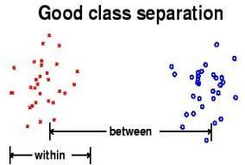

Figure 2.6 Class Separation in LDA (Suman Kumar Bhattacharyya and Kumar Rahul, 2013)

The original LBP (Local Binary Patterns) operator was introduced by the paper of Timo Ojala et al. (2002). In the paper by Md. Abdur Rahim et al. (2013), they proposed LBP to extract both texture details and contour to represent facial images. LBP divides each facial image into smaller regions and histogram of each region is extracted. The histograms of every region are concatenated into a single feature vector. This feature vector is the representation of the facial image and Chi square statistic is used to measure similarities between facial images. The smallest window size of each region is 3 by 3. It is computed by thresholding each pixel in a window where middle pixel is the threshold value. The neighborhood larger than threshold value is assigned to 1 whereas the neighborhood lower than threshold value is assigned to 0. Then the resulting binary pixels will form a byte value representing center pixel.

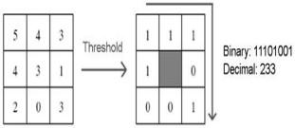

Figure 2.7 LBP Operator (Md. Abdur Rahim et.al, 2013)

LBP has a few advantages which make it popular to be implemented. It has high tolerance against the monotonic illumination changes and it is able to deal with variety of facial expressions, image rotation and aging of persons. These overwhelming characteristics cause LBP to be prevalent in real-time applications.

Neural network is initially used only in face detection. It is then further studied to be implemented in face recognition. In the paper by Manisha M. Kasar et al. (2016), Artificial Neural Network (ANN) was studied for face recognition. ANN consists of the network of artificial neurons known as "nodes". The nodes act as human brain in order to make recognition and classification. These nodes are interconnected and values are assigned to determine the strength of their connections. High value indicates strong connection. Neurons were categorized into three types of nodes or layers which are input nodes, hidden nodes, and output nodes. Input nodes are given weight based on its impact. Hidden nodes consist of some mathematical function and thresholding function to perform prediction or probabilities that determine and block unnecessary inputs and result is yield in output nodes. Hidden nodes can be more than one layer. Multiple inputs generate one output at the output node.

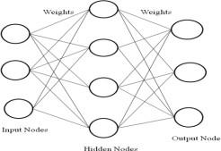

Figure 2.8 Artificial Neural Network (ANN) (Manisha M. Kasar et al., 2016)

Convolutional Neural Network (CNN) is another neural network algorithm for face recognition. Similar to ANN, CNN consists of the input layer, hidden layer and output layer. Hidden layers of a CNN consists of multiple layers which are convolutional layers, pooling layers, fully connected layers and normalization layers. However, a thousand or millions of facial images have to be trained for CNN to work accurately and it takes long time to train, for instance Deepface which is introduced by Facebook.

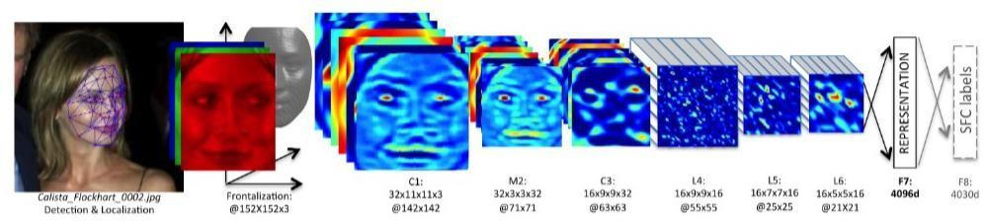

Figure 2.9 Deepface Architecture by Facebook (Yaniv Taigman et al, 2014)

#### 2.4.1 Types of Feature Extraction

Divyarajsinh N. Parmar and Brijesh B. Mehta (2013) face recognition system can be categorized into a few Holistic-based methods, Feature-based methods and Hybrid methods. Holistic-based methods are also known as appearance-based methods, which mean entire information about a face patch is involved and used to perform some transformation to obtain a complex representation for recognition. Example of Holistic-based methods are PCA(Principal Component Analysis) and LDA(Linear dependent Analysis).On the other hand, feature-based methods directly extract detail from specific points especially facial features such as eyes, noses, and lips whereas other information which is considered as redundant will be discarded. Example of feature-based method is LBP (Local Binary Pattern). These methods mentioned are usually combined to exist as Hybrid method, for example Holistic-based method combine with Feature-based in order to increase efficiency.

Face recognition system can be categorized into a few Holistic-based methods, Feature-based methods and Hybrid methods. Holistic-based methods are also known as appearance-based methods, which mean entire information about a face patch is involved and used to perform some transformation to obtain a complex representation for recognition.

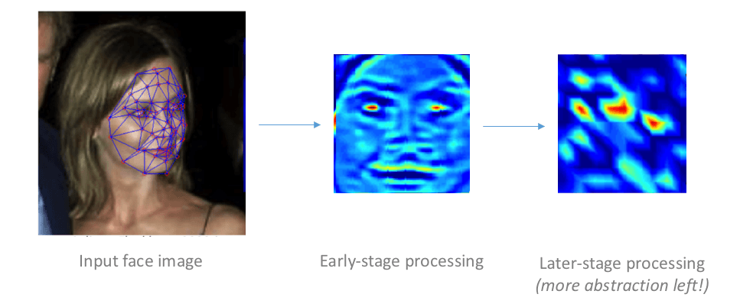

Figure 2.10 Feature Extraction (Yaniv Taigman et al, 2014)

#### 2.5 Feature Classification And Face Recognition

Classification involves the process of identification of face. Distance classifier finds the distance between the test image and train image based on the extracted features. The smaller the distance between the input feature points and the trained feature points, the higher the similarity of the test image and training image. In other words, the facial images with the smallest/minimum distance will be classified as the same person. Deepesh Raj (2011) mentioned several types of distance classifiers such as Euclidean Distance, City Block Distance and Mahalanobis distance for face recognition. Md. Abdur Rahim et al. (2013) implemented Chi-Square statistic as distance classifier for LBP operator. The equation of each classification method is defined below.

Chi square distance is defined as (2.1)

χ2 = ∑ oberved frequency−expected frequency.

expected frequency

Chi-square statistic is usually used to compare between two bins of histogram.

The City Block Distance or Manhattan Distance is known as L1-norm which is defined in (2.2)

d(x,y) = $\left|x-y\right|$

The Euclidean distance is known as L2-norm which is defined in (2.3)

d(x,y) = ${\left|x-y\right|}^{2}$

#### 2.6 Evaluation

Different databases are used in order to evaluate the system performance. The database provided by previous researchers with different variable conditions, for example, lighting and expression will be used to justify the system and for study purpose. Furthermore, our own database will be used to analyse the system for real time application. From the literature review of the previous researchers, the common method to justify the performance of the system is by finding the accuracy of recognition.

The formula for accuracy or recognition rate is defined below (2.5):

𝑡𝑜𝑡𝑎𝑙 𝑚𝑎𝑡𝑐ℎ𝑒𝑑 𝑖𝑚𝑎𝑔𝑒𝑠

𝑎𝑐𝑐𝑢𝑟𝑎𝑐𝑦 = 𝑥100

𝑡𝑜𝑡𝑎𝑙 𝑡𝑒𝑠𝑡𝑒𝑑 𝑖𝑚𝑎𝑔𝑒𝑠

Table 2.5 Summary of Feature Extraction, The Accuracy Obtained from Handbook of Research on Emerging Perspectives in Intelligent Pattern Recognition (NK Kamila, 2015)

|  |  |  |  |
| --- | --- | --- | --- |
| Method | Advantages | Disadvantages | Accuracy (ATT  database) |
| Eigen face/ Kernel PCA (Principal component  Analysis) | High speed in training and recognition. | Face recognition is depend on training database. | 77.97 % |
| Fisher face/ LDA  (Linear Discriminant Analysis ) | Images of individual with different illumination, facial expressions able to be recognized if more samples are trained. | 1. Bigger database is required because images of different expression of the individual have to be .trained in same class. 2. It depend more on database compared to PCA. | 82.45 % |
| LBP(Local Binary Pattern) | It is able to overcome variety of facial expressions, varying illumination, image rotation and aging of person. | Training time is longer than PCA and LDA. | 90.93 % |
| Neural network | High accuracy only if large database is trained. | 1. Required long time to train. 2. Database is extremely large to have high accuracy. | N.A |

#### CHAPTER 3

**METHODOLOGY**

#### 3.1 Methodology Flow

The approach performs face recognition based student attendance system. The methodology flow begins with the capture of image by using simple and handy interface, followed by pre-processing of the captured facial images, then feature extraction from the facial images, subjective selection and lastly classification of the facial images to be recognized. Both LBP and PCA feature extraction methods are studied in detail and computed in this proposed approach in order to make comparisons. LBP is enhanced in this approach to reduce the illumination effect. An algorithm to combine enhanced LBP and PCA is also designed for subjective selection in order to increase the accuracy. The details of each stage will be discussed in the following sections.

The flow chart for the proposed system is categorized into two parts, first training of images followed by testing images (recognize the unknown input image) shown in Figure 3.1 and Figure 3.2 respectively

#### 3.2 Input Images

Although our own database should be used to design real time face recognition student attendance system, the databases that are provided by the previous researchers are also used to design the system more effectively, efficiently and for evaluation purposes.

Yale face database is used as both training set and testing set to evaluate the performance. Yale face database contains one hundred and sixty-five grayscale images of fifteen individuals. There are eleven images per individual; each image of the individual is in different condition. The conditions included centre-light, with glasses, happy, left-light, without glasses, normal, right-light, sad, sleepy, surprised and wink. These different variations provided by the database is able to ensure the system to be operated consistently in variety of situations and conditions.

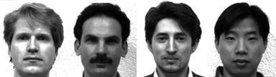

Figure 3.1 Sample Images in Yale Face Database (Cvc.cs.yale.edu, 1997)

For our own database, the images of students are captured by using laptop built in camera and mobile phone camera. Each student provided four images, two for training set and two for testing set. The images captured by using laptop built in camera are categorized as low quality images, whereas mobile phone camera captured images are categorized as high quality images. The high quality images consists of seventeen students while low quality images consists of twenty-six students. The recognition rate of low quality images and high quality images will be compared in Chapter 4 to draw a conclusion in term of performance between image sets of different quality.



Figure 3.2 Sample of High Quality Images



Figure 3.3 Sample of Low Quality Images

#### 3.3 Face Detection

Viola-Jones object detection framework will be used to detect the face from the video camera recording frame. The working principle of Viola-Jones algorithm is mentioned in Chapter 2. The limitation of the Viola-Jones framework is that the facial image has to be a frontal upright image, the face of the individual must point towards the camera in a video frame.

#### Working Principle of Original LBP

LBP is basically a texture based descriptor which it encoded local primitive into binary string. (Timo Ojala et al., 2002). The original LBP operator works on a 3 × 3 mask size. 3 × 3 mask size contains 9 pixels. The center pixel will be used as a threshold to convert the neighboring pixels (the other 8 pixels) into binary digit. If the neighboring pixel value is larger than the center pixel value, then it is assigned to 1, otherwise it is assigned to 0. After that, the neighborhoods pixel bits are concatenated to a binary code to form a byte value representing the center pixel. The center pixel will be used as a threshold to convert the neighboring pixels (the other pixels) into binary digit. The center pixel will be used as a threshold to convert the neighboring pixels (the other 8 pixels) into binary digit. Figure 3.6 shows an example of LBP conversion.

If the neighboring pixel value is larger than the center pixel value, then it is assigned to 1, otherwise it is assigned to 0. After that, the neighborhoods pixel bits are concatenated to a binary code to form a byte value representing the center pixel. . The center pixel will be used as a threshold to convert the neighboring pixels. The center pixel will be used as a threshold to convert the neighboring pixels (the other pixels) into binary digit.

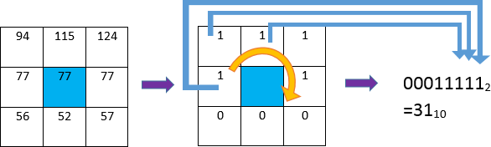

Figure 3.4 Example of LBP Conversion

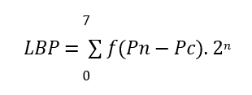

where Pc indicates centre pixel and Pn (n = 0,…, 7) are 8 of its neighbouring pixels respectively.

The starting point of the encoding process can be any of neighbouring pixels as long as the formation of binary string is following the order either in clockwise or anticlockwise rotation. The thresholding function f(y) can be written as follows

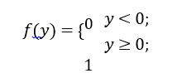

#### 3.3.2 Working Principle of Proposed LBP

The original LBP operator is composed of 3 × 3 filter size with 9 pixels. Instead of the circular pattern, it looks more rectangular in shape. The 9 pixels adjacent to each other means every detail will be taken as sampling points even the non-essential details. It is more affected by uneven lighting condition because the small filter size emphasizes small scale detail (Lee and Li, 2007), even the shadow created by non-uniform lighting condition. In our proposed approach, a larger radius size, R is implemented in LBP operator. In the paper of Md. Abdur Rahim et.al (2013), the equation of modifying the radius size has been introduced. However, the paper did not mention the effect of changing the radius size. In the proposed approach, analysis is done on different radius sizes in order to enhance the system and reduce the illumination effect.

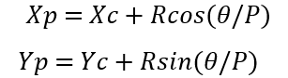

Although the radius has been increased, total 8 sampling points are taken which is similar to the original LBP operator. In the approach, CLAHE is performed on the grayscale input facial images to improve the contrast .

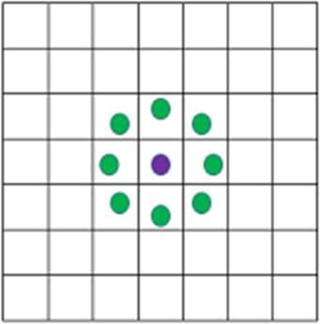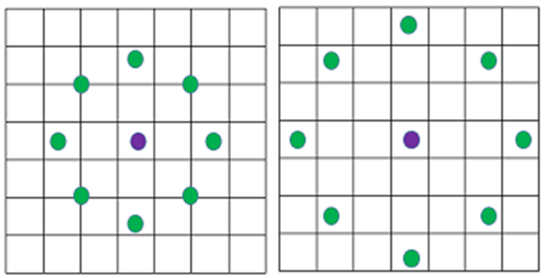

R=1(original) R=2 R=3

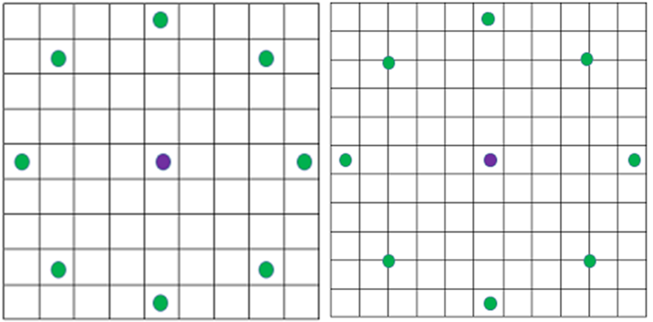

R=4 R=5

Figure 3.5 LBP with Different Radius Sizes

Basically, the increasing in the size of the radius means extending the circular pattern of LBP externally. The green spots within the blocks indicate the sampling pixels to be encoded into binary string .

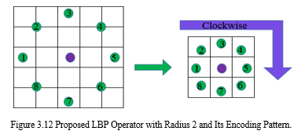

Figure 3.6 Proposed LBP Operator with Radius 2 and Its Encoding Pattern.

.

The feature vector of the image is constructed after the Local Binary Pattern of every pixel is calculated. The histogram of the feature vector image is computed in order to be classified by distance classifier. However, it loss spatial information because histogram representation does not include spatial information but only discrete information. (Gonzalez*,* R. C.*, &* Woods, 2008). In order to overcome this problem, the feature vector image is then divided into blocks. A histogram is constructed in each region respectively. Every bin in a histogram represents a pattern and contains the frequency of its appearance in the region. The feature vector of entire image is then constructed by concatenating the regional histograms in the sequence to one histogram. (Md. Abdur Rahim et al., 2013). This histogram remains its regional spatial information and represents the identity of single image which is then classified to perform the recognition.

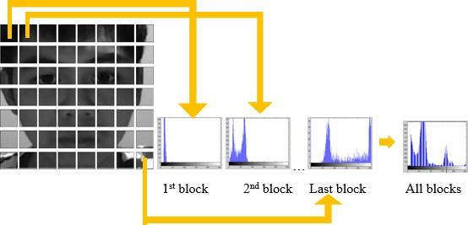

Figure 3.7 Histogram of Image Blocks

**3.3.3 Working Principle of PCA**

In this proposed approach, PCA face recognition is studied, as it is one of the popular face recognition methods that was suggested and used by the previous researchers. The accuracy of PCA is computed in order to compare with the enhanced LBP.

PCA includes a few steps which will briefly be described in the following paragraphs. For PCA, the image scale, length (M) and height (M) is not so important. This is because PCA is mostly dealing with number of total images, N instead of M. However, same size of test image and training image is a must for PCA computation. Same length and height of the image is assumed in the following equation for illustration. Given a training set of N images with size 𝑀 × 𝑀, the first step of PCA is to convert two dimensional vectors to one dimensional vector. The one dimensional vector can be either column vector or row vector. In this approach, the column vector conversion is done. For each facial image with matrix notation 𝑀 × 𝑀 will be converted to column vector Γi, with dimension 𝑀2 × 1.There are N facial images, each face is represented by column vector Γ1, Γ2, Γ3, .., ΓN. Feature vector of each face is stored in this column vector. The dimension reduced face matrix is constructed by concatenating every single column vector.

#### 3.4 Feature Classification

Chi-square statistic is used as a dissimilarity measure for LBP to determine the shortest distance between training image and the testing image. On the other hand, Euclidean distance is used to compute the shortest distance between trained and test image after PCA feature extraction. Both classifiers, Chi-square statistic and Euclidean distance determine the closest or nearest possible training image to the testing image for face recognition. However, the nearest result might not be always true. Therefore, an algorithm to combine enhanced LBP and PCA is applied in order to increase the accuracy of the system.

#### 3.4.1 Subjective Selection Algorithm and Face Recognition

The feature classification that has been performed in previous part gives the closest result but not absolute. In order to increase the accuracy and suppress the false recognition rate, an algorithm to combine enhanced LBP and PCA is designed in this proposed approach.

In this proposed approach, best five results are obtained from enhanced LBP and PCA. This means that five individuals which have closest distance with respect to input image will be identified. LBP and PCA are two different algorithms which have a different working principleLBP is designed to have higher priority compared to PCA. This is shown in the Figure 3.14, Student_1 is recognized instead of Student_3 because LBP is prioritized. As a result, the first common individual is selected from PCA with respect to LBP and classified as recognized. If there is no common term between LBP and PCA then the system will not recognize any subject. This subjective selection algorithm is designed to be automated in the system.

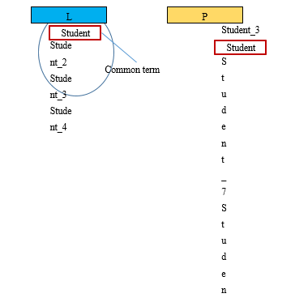

The input image will be recognized as Student_1

Figure 3.8 Subjective Selection Algorithm

#### CHAPTER 4

**RESULT AND DISCUSSION**

#### Result

In this proposed approach, face recognition student attendance system with user- friendly interface is designed by using MATLAB GUI (Graphic User Interface). A few buttons are designed in the interface, each provides specific function, for example, start button is to initialize the camera and to perform face recognition automatically according to the face detected, register button allows enrolment or registrations of students and update button is to train the latest images that have been registered in the database. Lastly, browse button and recognize button is to browse facial images from selected database and recognized the selected image to test the functionality of the system respectively.

In this part, enhanced LBP with radius two is chosen and used as proposed algorithm. The analysis of choosing the radius size will be further explained in the discussion.

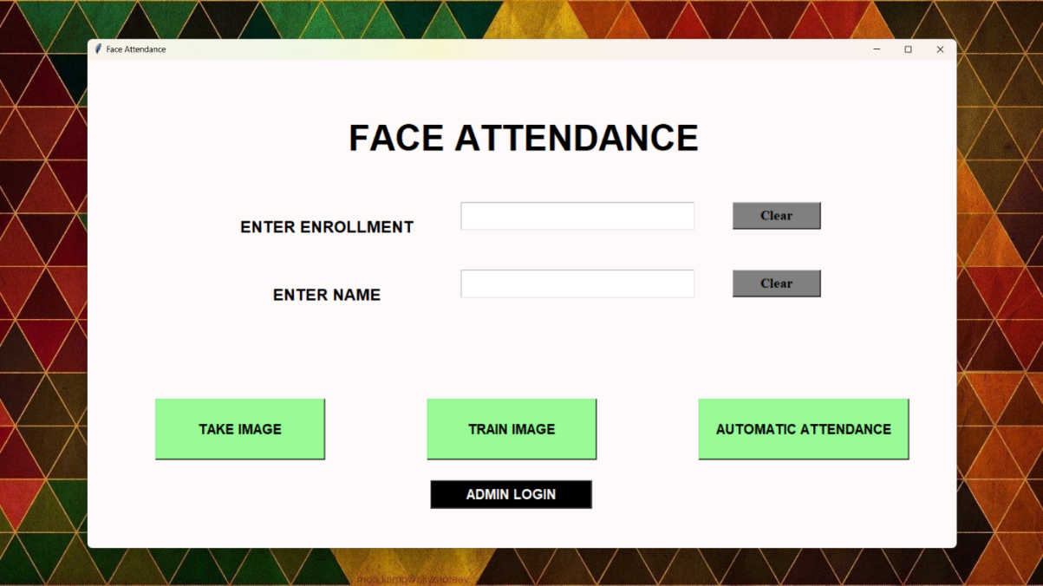

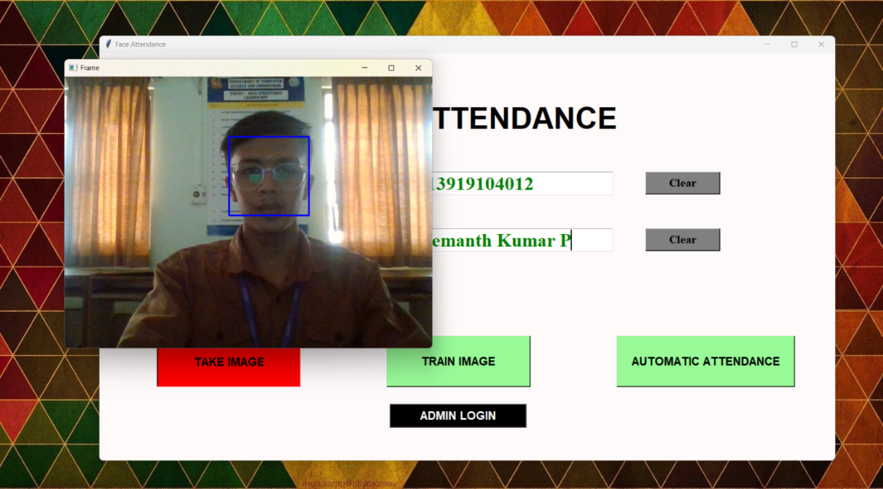

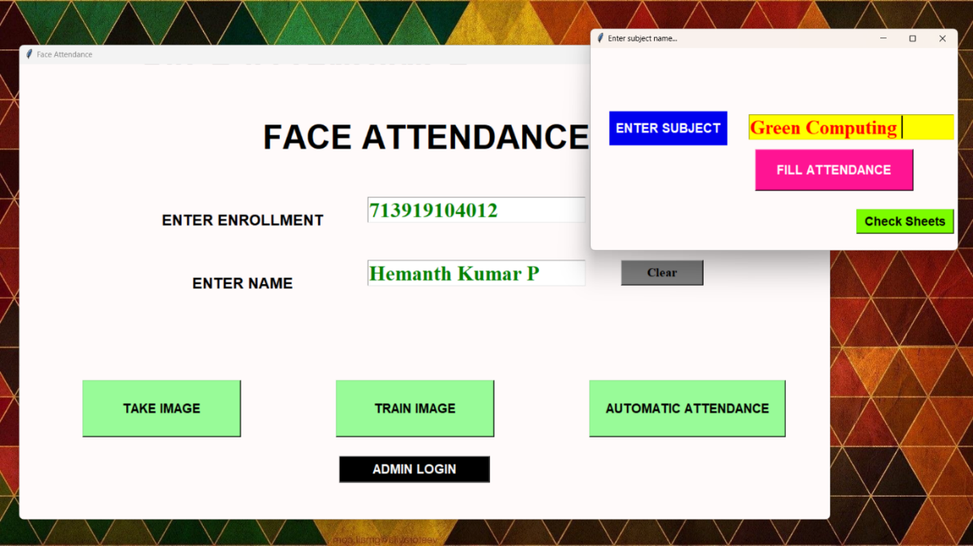

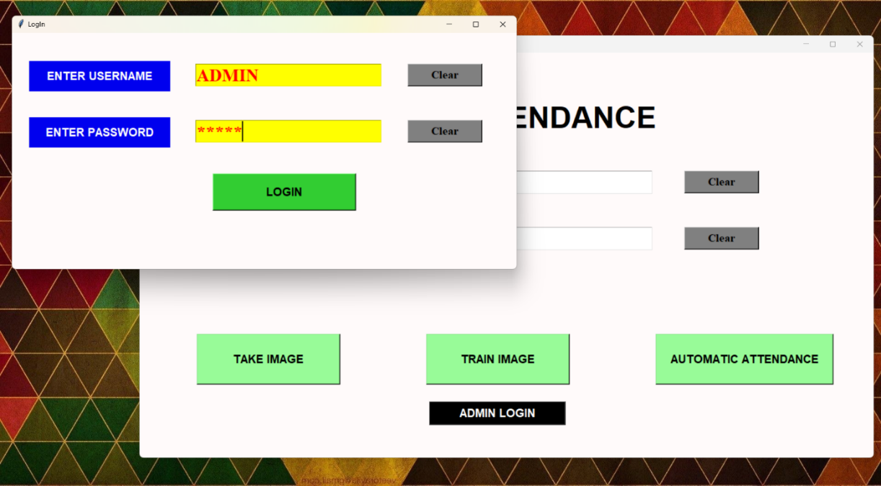

#### Discussion

This proposed approach provides a method to perform face recognition for the student attendance system, which is based on the texture based features of facial images. Face recognition is the identification of an individual by comparing his/her real-time captured image with stored images in the database of that person. Thus, the training set has to be chosen based on the latest appearance of an individual other than taking important factors for instance illumination into consideration.

The proposed approach is being trained and tested on different datasets. Yale face database which consists of one hundred and sixty-five images of fifteen individuals with multiple conditions is implemented. However, this database consists of only grayscale images.

Viola-Jones object detection framework is applied in this approach to detect and localize the face given a facial image or provided a video frame. From the detected face, an algorithm that can extract the important features to perform face recognition is designed.

 The fact that, the radius might not be the larger the better because larger radius with respect to larger filter size emphasizes complementary information to small scale detail but at the same time it loss discriminative information. The discriminative information is important, for instance to recognize students with glasses free condition.

Figure 4.1 Images of Students With or Without Wearing Glasses

However, it does prove that the enhanced LBP operator with increased radius performs better compared to original LBP in case of illumination effect reduction

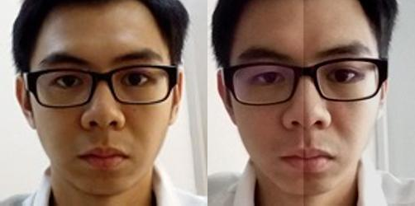From the result, the condition II appears to have lower accuracy compared to others. This is due to the lighting effect of the training image. The training images have its left side relatively darker compared to its right side which is directly opposite of the test image (condition II)

Training Image Test Image

(Condition II)

Figure 4.2 Training Image VS Testing Image

From the result of proposed LBP in Table 4.6, database with good quality colour images, achieves the highest accuracy (100 %) either one image or two images per individual is trained whereas database with poor quality color images have average accuracy of (86.54 %) when only one image per individual is trained and average accuracy of (88.46 %) when two images per individual are trained. It can be said that the approach works best with good quality images, poor quality images could degrade the performance of the algorithm. Poor quality images were captured by using Laptop camera.

**CHAPTER 5**

**SYSTEM REQUIREMENTS**

**5.1 HARDWARE SPECIFICATION**

RAM 4 GB

Processor Intel i5

Camera

Keyboard

**5.2 SOFTWARE SPECIFICATION**

IDE VS CODE

Language Python

Front end Tkinter

Back end PyMySql

OS Windows 10 and above

**VSCODE**

VSCode or Visual Studio Code, is a popular source code editor developed by Microsoft. It is widely used by developers for various programming languages and provides a range of features to enhance the coding experience. While VSCode itself is a software application and not a hardware requirement, it can be installed on different operating systems such as Windows, macOS, and Linux.

**5.3 PYTHON LIBRARIES AND MODULES**

Python is a high-level programming language known for its simplicity, readability, and versatility. It was created by Guido van Rossum and first released in 1991. Python emphasizes code readability, utilizing a clean and easy-to-understand syntax. It uses indentation and whitespace to define code blocks, making it visually clear and reducing the need for explicit delimiters. Python is beginner-friendly and considered one of the most accessible programming languages to learn. Its syntax is straightforward and resembles natural language, making it intuitive for new programmers.

Python is a multipurpose language that can be used for various applications, including web development, data analysis, scientific computing, artificial intelligence, machine learning, and more.

Python's popularity and widespread adoption in both academia and industry can be attributed to its ease of use, extensive libraries, and versatility. It continues to evolve with regular updates and improvements, making it a powerful language for a wide range of applications and domains.

Python is a versatile programming language that offers a wide range of libraries and modules to extend its functionality and simplify various tasks.

These are just a few examples of the vast library ecosystem available in Python. Depending on your specific needs and interests, you can explore and leverage various libraries to enhance your Python programming experience and solve different problems efficiently.

**TKINTER**

Tkinter is a standard Python library used for creating graphical user interfaces (GUIs). It provides a simple and intuitive way to build windows, dialog boxes, buttons, menus, and other GUI elements for desktop applications. Tkinter is included with Python installations, making it readily available for developers.

While Tkinter is a powerful tool for creating GUIs, it is important to note that it has some limitations in terms of complex UI designs and modern aesthetics. For more advanced or specialized GUI requirements, other libraries like PyQt or wxPython might be more suitable.

Tkinter remains a popular choice for many Python developers due to its simplicity, ease of use, and compatibility with different platforms. It provides a solid foundation for building desktop applications with graphical interfaces. Tkinter is included with Python installations, making it readily available for developers.

**PYMYSQL**

PyMySQL is a Python library that provides a pure-Python interface for connecting to and interacting with MySQL databases. It allows you to perform various database operations such as querying data, inserting, updating, and deleting records, creating tables, and executing SQL statements.

PyMySQL is a popular choice for working with MySQL databases in Python due to its simplicity, reliability, and compatibility with the Python database API specification. It offers a convenient and efficient way to interact with MySQL databases using Python code.

**PANDAS**

Pandas is a powerful open-source data manipulation and analysis library for Python. It provides easy-to-use data structures and data analysis tools, making it popular for tasks such as data cleaning, data transformation, and data exploration.

Pandas is widely used in various domains, including data analysis, machine learning, finance, social sciences, and more. Its versatility, ease of use, and extensive functionality make it a go-to library for data manipulation .

**NUMPY**

NumPy (Numerical Python) is a powerful open-source library for numerical computing in Python. It provides support for large, multi-dimensional arrays and matrices, along with a collection of mathematical functions to operate on these arrays efficiently.

NumPy is widely used in various domains, including scientific computing, data analysis, machine learning, image processing, and more. Its efficient array operations and mathematical functions make it a fundamental library for numerical computing in Python.

**PIL**

PIL (Python Imaging Library), also known as Pillow, is a popular open-source library for image processing and manipulation in Python. It provides a wide range of image editing capabilities, making it a valuable tool for tasks such as opening, manipulating, and saving different image file formats. PIL allows you to open, create, and save images in various formats, including JPEG, PNG, GIF, BMP, and TIFF.

PIL is widely used in various applications, such as image processing pipelines, computer vision tasks, web development, and digital art. Its user-friendly interface and extensive functionality make it a popular choice for working with images in Python.

**CV2**

The cv2 module in Python is part of OpenCV (Open Source Computer Vision Library), which is a popular library for computer vision tasks and image processing. The cv2 module provides various functions and classes for working with images and videos. OpenCV provides a wide range of image processing techniques such as thresholding, edge detection, image filtering, morphological operations, and more

**CSV**

CSV (Comma-Separated Values) is a common file format used for storing tabular data, where each line represents a row and the values within each line are separated by commas. Python provides a built-in csv module that makes it easy to read from and write to CSV files.

The csv.reader and csv.writer objects provide methods to read and write CSV data, respectively. The csv.reader reads the CSV file line by line, and each line is treated as a list of values. The csv.writer writes data to the CSV file based on the provided data structure.

**OS**

In Python, the os module provides a way to interact with the operating system. It offers functions and methods to perform various operations related to the operating system, such as file and directory management, process management, environment variables, and more.

the os module. It allows you to perform various operations related to the operating system, making it easier to work with files, directories, processes, and environment variables within your Python programs.

**DATETIME**

The datetime module in Python provides classes and functions to work with dates, times, and time intervals. It allows you to perform various operations involving dates and times, such as creating, manipulating, and formatting them.

The datetime module is widely used in various applications involving date and time calculations, event scheduling, data analysis, and more. It provides a flexible and comprehensive set of tools for working with dates and times in Python

#### CHAPTER 6

**CONCLUSION AND RECOMMENDATION**

#### Conclusion

In this approach, a face recognition based automated student attendance system is thoroughly described. The proposed approach provides a method to identify the individuals by comparing their input image obtained from recording video frame with respect to train image. This proposed approach able to detect and localize face from an input facial image, which is obtained from the recording video frame. Besides, it provides a method in pre-processing stage to enhance the image contrast and reduce the illumination effect. Extraction of features from the facial image is performed by applying both LBP and PCA. The algorithm designed to combine LBP and PCA able to stabilize the system by giving consistent results. The accuracy of this proposed approach is 100 % for high-quality images, 92.31 % for low-quality images and 95.76 % of Yale face database when two images per person are trained.

As a conclusion for analysis, the extraction of facial feature could be challenging especially in different lighting. In pre-processing stage, Contrast Limited Adaptive Histogram Equalization (CLAHE) able to reduce the illumination effect. CLAHE perform better compared to histogram equalization in terms of contrast improvement. Enhanced LBP with larger radius size specifically, radius size two, perform better compared to original LBP operator, with less affected by illumination and more consistent compared to other radiu sizes.

#### Recommendation

In this proposed approach, there are a few limitations. First, the input image has to be frontal and a upright single facial image. Second, the accuracy might drop under extreme illumination problem. Third, false recognition might occur if the captured image is blurred. Besides, LBP is textural based descriptor which extracts local features. Hence, test image and train image have to be the same quality which is captured by using the same device in order to have high accuracy. Lastly, if an individual wears make up in the image for face recognition, the important features will be covered.

In fact, a better camera with a better lighting source able to reduce the illumination problem and also able to avoid the captured of blurred images. In this proposed approach, laptop built in camera is a default device. However the lighting source of the laptop camera is very dim, this cause the system to be unstable. For future work, a better camera and a better lighting source can be used in order to obtain better result. This can reduce the dependency on the brightness of environment, especially the places to capture test and train images. Furthermore, a face recognition system which has more faces other than a single facial image can be designed. This can increase the efficiency of the system. The test image and train image in this approach is highly related to each other and highly dependent on the image captured device. The capture device has to be the same for this approach to perform better. Thus, other algorithms can be used instead of LBP, for example A.I (artificial intelligence) algorithm which can be implemented to perform the face recognition. CNN (Convolution Neural Network) which is a hot topic recently, is a machine deep learning algorithm which is able to perform recognition with less dependency on a particular train image given a large database.

**APPENDIX**

import tkinter as tk

from tkinter import *

import cv2

import csv

import os

import numpy as np

from PIL import Image,ImageTk

import pandas as pd

import datetime

import time

window = tk.Tk()

window.title("Face Attendance")

window.geometry('1280x720')

window.configure(background='snow')

def manually_fill():

global sb

sb = tk.Tk()

sb.title("Please enter subject Name :-")

sb.geometry('580x320')

sb.configure(background='snow')

def err_screen_for_subject():

def ec_delete():

ec.destroy()

global ec

ec = tk.Tk()

ec.geometry('300x100')

ec.title('Warning!!')

ec.configure(background='snow')

Label(ec, text='Please enter your subject name!!!', fg='red', bg='white', font=('times', 16, ' bold ')).pack()

Button(ec, text='OK', command=ec_delete, fg="black", bg="lawn green", width=9, height=1, activebackground="Red",

font=('times', 15, ' bold ')).place(x=90, y=50)

def fill_attendance():

ts = time.time()

Date = datetime.datetime.fromtimestamp(ts).strftime('%Y_%m_%d')

timeStamp = datetime.datetime.fromtimestamp(ts).strftime('%H:%M:%S')

Time = datetime.datetime.fromtimestamp(ts).strftime('%H:%M:%S')

Hour, Minute, Second = timeStamp.split(":")

date_for_DB = datetime.datetime.fromtimestamp(ts).strftime('%Y_%m_%d')

global subb

subb=SUB_ENTRY.get()

DB_table_name = str(subb + "_" + Date + "_Time_" + Hour + "_" + Minute + "_" + Second)

import pymysql.connections

global cursor

try:

global mycursor

connection = pymysql.connect(host='localhost', user='root', password='root', db='manually_fill_attendance')

mycursor = connection.cursor()

except Exception as e:

print(e)

sql = "CREATE TABLE " + DB_table_name +

""" (ID INT NOT NULL AUTO_INCREMENT,

ENROLLMENT varchar(100) NOT NULL,

NAME VARCHAR(50) NOT NULL,

DATE VARCHAR(20) NOT NULL,

TIME VARCHAR(20) NOT NULL,

PRIMARY KEY (ID) );"""

try:

mycursor.execute(sql) ##for create a table

except Exception as ex:

print(ex) #

if subb=='':

err_screen_for_subject()

else:

sb.destroy()

MFW = tk.Tk()

MFW.geometry('880x470')

MFW.configure(background='snow')

def del_errsc2():

errsc2.destroy()

def err_screen1():

global errsc2

errsc2 = tk.Tk()

errsc2.geometry('330x100')

errsc2.title('Warning!!')

errsc2.configure(background='snow')

Label(errsc2, text='Please enter Student & Enrollment!!!', fg='red', bg='white',

font=('times', 16, ' bold ')).pack()

Button(errsc2, text='OK', command=del_errsc2, fg="black", bg="lawn green", width=9, height=1,

activebackground="Red", font=('times', 15, ' bold ')).place(x=90, y=50)

def testVal(inStr, acttyp):

if acttyp == '1': # insert

if not inStr.isdigit():

return False

return True

ENR = tk.Label(MFW, text="Enter Enrollment", width=15, height=2, fg="white", bg="blue2",

font=('times', 15, ' bold '))

ENR.place(x=30, y=100)

STU_NAME = tk.Label(MFW, text="Enter Student name", width=15, height=2, fg="white", bg="blue2",

font=('times', 15, ' bold '))

STU_NAME.place(x=30, y=200)

global ENR_ENTRY

ENR_ENTRY = tk.Entry(MFW, width=20,validate='key', bg="yellow", fg="red", font=('times', 23, ' bold '))

ENR_ENTRY['validatecommand'] = (ENR_ENTRY.register(testVal), '%P', '%d')

ENR_ENTRY.place(x=290, y=105)

def remove_enr():

ENR_ENTRY.delete(first=0, last=22)

STUDENT_ENTRY = tk.Entry(MFW, width=20, bg="yellow", fg="red", font=('times', 23, ' bold '))

STUDENT_ENTRY.place(x=290, y=205)

def remove_student():

STUDENT_ENTRY.delete(first=0, last=22)

def enter_data_DB():

ENROLLMENT = ENR_ENTRY.get()

STUDENT = STUDENT_ENTRY.get()

if ENROLLMENT=='':

err_screen1()

elif STUDENT=='':

err_screen1()

else:

time = datetime.datetime.fromtimestamp(ts).strftime('%H:%M:%S')

Hour, Minute, Second = time.split(":")

Insert_data = "INSERT INTO " + DB_table_name + " (ID,ENROLLMENT,NAME,DATE,TIME) VALUES (0, %s, %s, %s,%s)"

VALUES = (str(ENROLLMENT), str(STUDENT), str(Date), str(time))

try:

mycursor.execute(Insert_data, VALUES)

except Exception as e:

print(e)

ENR_ENTRY.delete(first=0, last=22)

STUDENT_ENTRY.delete(first=0, last=22)

def create_csv():

import csv

mycursor.execute("select * from " + DB_table_name + ";")

csv_name='./Manually Attendance/'+DB_table_name+'.csv'

with open(csv_name, "w") as csv_file:

csv_writer = csv.writer(csv_file)

csv_writer.writerow([i[0] for i in mycursor.description]) # write headers

csv_writer.writerows(mycursor)

O="CSV created Successfully"

Notifi.configure(text=O, bg="Green", fg="white", width=33, font=('times', 19, 'bold'))

Notifi.place(x=180, y=380)

import csv

import tkinter

root = tkinter.Tk()

root.title("Attendance of " + subb)

root.configure(background='snow')

with open(csv_name, newline="") as file:

reader = csv.reader(file)

r = 0

for col in reader:

c = 0

for row in col:

label = tkinter.Label(root, width=13, height=1, fg="black", font=('times', 13, ' bold '), bg="lawn green", text=row, relief=tkinter.RIDGE) label.grid(row=r, column=c)

root.mainloop()

def getImagesAndLabels(path):

imagePaths = [os.path.join(path, f) for f in os.listdir(path)]

faceSamples = []

Ids = []

for imagePath in imagePaths:

pilImage = Image.open(imagePath).convert('L')

imageNp = np.array(pilImage, 'uint8')

Id = int(os.path.split(imagePath)[-1].split(".")[1])

faces = detector.detectMultiScale(imageNp)

for (x, y, w, h) in faces:

faceSamples.append(imageNp[y:y + h, x:x + w])

Ids.append(Id)

return faceSamples, Ids

window.grid_rowconfigure(0, weight=1)

window.grid_columnconfigure(0, weight=1)

def on_closing():

from tkinter import messagebox

if messagebox.askokcancel("Quit", "Do you want to quit?"):

window.destroy()

window.protocol("WM_DELETE_WINDOW", on_closing)

message = tk.Label(window, text="FACE ATTENDANCE", bg="snow", fg="black", width=35,

height=3, font=('Bebas Neue', 40 , 'bold'))

message.place(x=80, y=20)

Notification = tk.Label(window, text="All things good", bg="Green", fg="white", width=15,

height=3, font=('times', 17, 'bold'))

lbl = tk.Label(window, text="ENTER ENROLLMENT", width=20, height=3, fg="black", bg="snow", font=('kenit', 18, ' bold '))

lbl.place(x=200, y=200)

def testVal(inStr,acttyp):

if acttyp == '1': #insert

if not inStr.isdigit():

return False

return True

txt = tk.Entry(window, validate="key", width=20, bg="white", fg="green", font=('times', 25, ' bold '))

txt['validatecommand'] = (txt.register(testVal),'%P','%d')

txt.place(x=550, y=210)

lbl2 = tk.Label(window, text="ENTER NAME", width=20, fg="black", bg="snow", height=3, font=('kenit', 18, ' bold '))

lbl2.place(x=200, y=300)

clearButton = tk.Button(window, text="Clear",command=clear,fg="black" ,bg="gray" ,width=10 ,height=1 ,activebackground = "Red" ,font=('times', 15, ' bold '))clearButton.place(x=950, y=210)

clearButton1 = tk.Button(window, text="Clear",command=clear1,fg="black" ,bg="gray" ,width=10 ,height=1, activebackground = "Red" ,font=('times', 15, ' bold '))clearButton1.place(x=950, y=310)

AP = tk.Button(window, text="ADMIN LOGIN",command=admin_panel,fg="white" ,bg="black" ,width=19 ,height=1, activebackground = "Red" ,font=('kenit', 15, ' bold '))

AP.place(x=505, y=620)

takeImg = tk.Button(window, text="TAKE IMAGE",command=take_img,fg="black" ,bg="pale green" ,width=20 ,height=3, activebackground = "Red" ,font=('kenit', 15, ' bold '))

takeImg.place(x=100, y=500)

trainImg = tk.Button(window, text="TRAIN IMAGE",fg="black",command=trainimg ,bg="pale green" ,width=20 ,height=3, activebackground = "Red" ,font=('kenit', 15, ' bold '))

trainImg.place(x=500, y=500)

FA = tk.Button(window, text="AUTOMATIC ATTENDANCE",fg="black",command=subjectchoose ,bg="pale green" ,width=25 ,height=3, activebackground = "Red" ,font=('kenit', 15, ' bold '))FA.place(x=900, y=500)

command=manually_fill ,fg="black" ,bg="thistle" ,width=20 ,height=3, activebackground = "Red" ,font=('times', 15, ' bold '))

window.mainloop()

#### REFERENCES

Robinson-Riegler, G., & Robinson-Riegler, B. (2008). Cognitive psychology: applying the science of the mind. Boston, Pearson/Allyn and Bacon.

Margaret Rouse. (2012). What is facial recognition? - Definition from WhatIs.com. [online] Available at:

[http://whatis.techtarget.com/definition/facial-recognition](http://whatis.techtarget.com/definition/facial-recognition%20)

Solon, O. (2017). Facial recognition database used by FBI is out of control, House committee hears. [online] the Guardian.Availableat: https:/[/www.theguardi](http://www.theguardian.com/technology/2017/mar/27/us-facial-recognition-)a[n.com/technology/2017/mar/27/us-facial-recognition-](http://www.theguardian.com/technology/2017/mar/27/us-facial-recognition-) database-fbi-drivers-licenses-passports

[Robert Silk](http://www.travelweekly.com/Robert-Silk). (2017). Biometrics: Facial recognition tech coming to an airport near you: Travel Weekly. [online] Available at:

<http://www.travelweekly.com/Travel-News/Airline-News/Biometrics-Facial-> recognition-tech-coming-airport-near-you

[Sidney Fussell.](https://kinja.com/sidneyfussell#_ga%3D2.33904934.647560575.1521956578-2116359232.1521956578) (2018). NEWS Facebook's New Face Recognition Features: What We Do (and Don't) Know. [online] Available at:

https://gizmodo.com/facebooks-new-face-recognition-features-what-we-do-an- 1823359911

deAgonia, M. (2017). Apple's Face ID [The iPhone X's facial recognition tech explained]. [online] Computerworld. Availableat: https:/[/www.comput](http://www.computerworld.com/article/3235140/apple-ios/apples-face-id-the-)e[rworld.com/article/3235140/apple-ios/apples-face-id-the-](http://www.computerworld.com/article/3235140/apple-ios/apples-face-id-the-) iphone-xs-facial-recognition-tech-explained.html

Ashley DuVal. (2012).Face Recognition Software -History of Forensic Psychology. [online] Available at:

<http://forensicpsych.umwblogs.org/research/criminal-justice/face-recognition-> software

[Jesse Davis West](https://www.facefirst.com/blog/brief-history-of-face-recognition-software/). (2017). History of Face Recognition - Facial recognition software. [online] Available at: https://[www.facefirst.com/blog/brief-history-of-face-](http://www.facefirst.com/blog/brief-history-of-face-) recognition-software

Reichert, C. (2017). Intel demos 5G facial-recognition payment technology | ZDNet. [online] ZDNet. Available at:<http://www.zdnet.com/article/intel-demos-5g-facial-recognition-payment-> technology

.